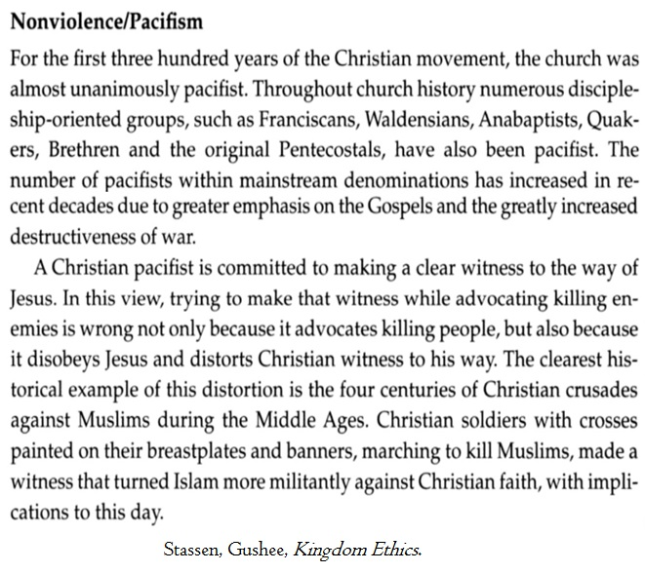
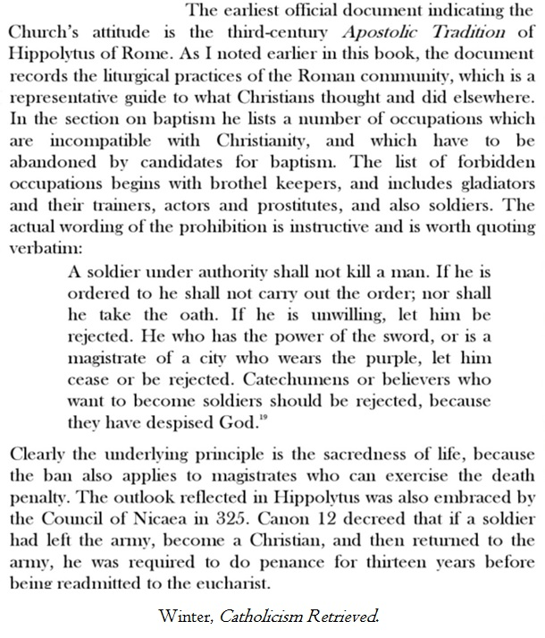
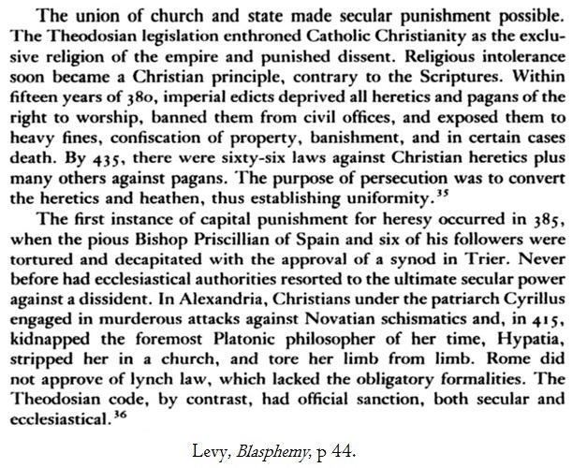
The First Missionary War, Chapter 1, Michael Routery, 1997:
“The Christian religion has, so often, spread through violence, force and coercion. Yet, its advocates, who have written the histories most of us learned in school, portray it as having been joyfully embraced by the ancient world, a loving embrace whose only restriction was imposed by the corrupt Roman state like a mean father with an innocent child…In truth, the Roman Church triumphed by marrying the Empire in that most fateful of centuries, the 4th [i.e., Nicea], and for the most part people converted because they were terrorized into doing so or forced to by ferociously repressive new laws…The new religion set itself apart from others, particularly, in its jealousy and extreme intolerance of any other spiritualties [i.e., paganism].”

The Founder’s Bible, Romans 13:
“Could Christian rulers prohibit other Christians from following what they believed to be clear scriptural teachings? …This question was addressed in American pulpits at the time. [Many believed that] God would not bless an offensive war. [Illustrative of this belief] was the famous command to the Lexington Minutemen, “Don’t fire unless fired upon!”

John Jay, “Founding Father”:
“It’s true that even just war is attended with evils and so likewise is the administration of government and of justice; but is that a good reason for abolishing either of them? They are means by which greater evils are averted…To prevent the incursion or continuance of evils, we must submit to the use of those means, whether agreeable or otherwise…”

Greg Boyd, Gods’ Way of War:
“Yahweh forbade those who served as temple priests to engage in violence [Num. 1-2; 4; 8]. When the NT later refers to the body of Christ as a royal priesthood, this is at least part of what it has in mind. While non-followers of Jesus may consider the use of violence in certain ‘justified’ circumstances to be necessary, if not praiseworthy, the royal priesthood of Jesus followers are called and empowered to bear witness to God’s non-violent ideal by altogether abstaining from it.”

