Tertullian, Treatise on the Crown:
“Shall it be held lawful to make an occupation of the sword, when the Lord proclaims that he who uses the sword shall perish by the sword? And shall the son of peace take part in the battle when it does not become him even to sue at law? Shall he carry a flag, too, hostile to Christ? Is the laurel of the triumph made of leaves, or of corpses? Is it adorned with ribbons, or with tombs? Is it sprinkled with ointments, or with the tears of wives & mothers? It may be of some Christians too; for Christ is also among the barbarians…On the contrary, if a soldier is converted he must abandon the military immediately.”

Justin Martyr, First Apology:
“The devil is the author of all war. We, who used to kill one another, do not make war on our enemies. We refuse to tell lies or deceive our inquisitors; we prefer to die acknowledging Christ.”

Origen Against Celsus 3.7:
“If a revolution had led to the formation of the [Church], so that it derived its existence in this way from that of the Jews, who were permitted to take up arms in defense of the members of their families, and to slay their enemies, [Jesus] would not have altogether forbidden the putting of men to death; and yet He nowhere teaches that it is right for His own disciples to offer violence to any one, however wicked. For He did not…allow the killing of any individual for any reason. [Instead] it was their fate to be slain as sheep, & on any occasion to resist their persecutors.”

Athenagoras, A Plea for Christians 35:
“[People know] that we cannot endure even to see a man put to death, though justly…But we, deeming that to see a man put to death is much the same as killing him, reject such spectacles. How, then, when we do not even look on, lest we should contract guilt and pollution, can we put people to death? And when we say that those women who use drugs to bring on abortion commit murder, and will have to give an account to God for the abortion, on what principle should we commit murder?”

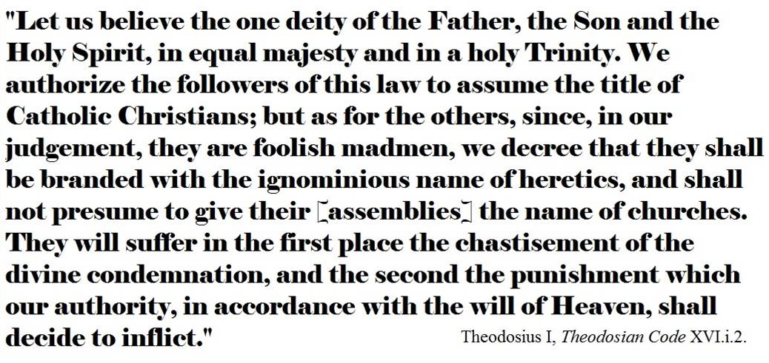
On War: https://rogueminister.wordpress.com/2008/11/19/quotes-the-early-church-on-war-and-violence/
On Abortion: http://www.priestsforlife.org/magisterium/earlychurchfathers/fatherscover.html
Recommended Readings
(Thanks to S. Finnegan)

1. Bercot, David, The Kingdom that Turned the World Upside Down.
2. Bonhoeffer, D, The Cost of Discipleship.
3. Boyd, Gregory, The Myth Of A Christian Nation.
4. Brensinger & Sider, Within the Perfection of Christ.
5. Camp, Lee, Mere Discipleship.
6. Clouse, R.G. War: Four Christian Views.
7. Dodge, D.L. War Inconsistent with the Religion of Jesus Christ.
8. Drescher, J.M. Why I Am a Conscientious Objector.
9. Egan, Peace Be With You: Justified Warfare or the Way of Non-Violence.
10. Ford, J.M. My Enemy is My Guest.
11. Gray, J.G. The Warriors: Reflection of Men in Battle.
12. Grossman, On Killing.
13. Harnack, Militia Christi.
14. Claibourne, S, Jesus for President.
15. Joseph, S.J. The Nonviolent Messiah.
16. MacArthur, John, Why Government Can’t Save You.
17. McCarthy, E.C. Christian Just War Theory: The Logic of Deceit.
18. MLK, Strength to Love.
19. Roth, J.D. Choosing Against War.
20. Sprinkle, P. Fight: A Christian Case for Non-Violence.
21. Stassen & Gushee, Kingdom Ethics.
22. Taylor, Dean, A Change of Allegiance.
23. Tolstoy, Leo, The Kingdom Of God Is Within You.
24. Wink, W, Jesus and Nonviolence.
25. Yoder, J, The Politics of Jesus; What Would You Do.
26. York & Barringer, A Faith Not Worth Fighting For.

