Looking past matthew 24

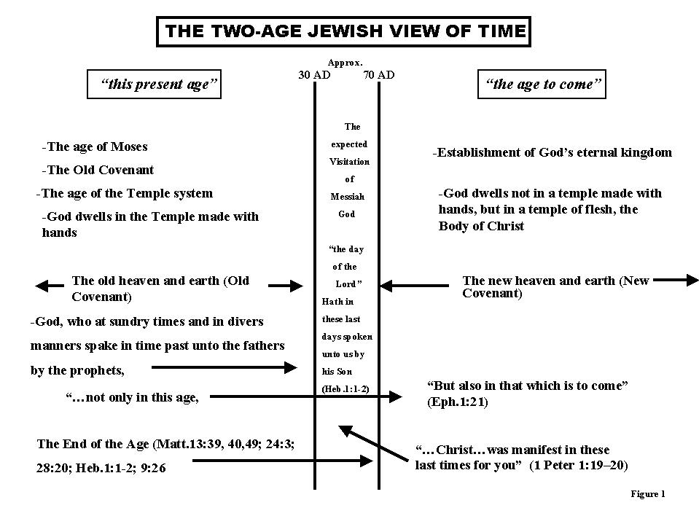
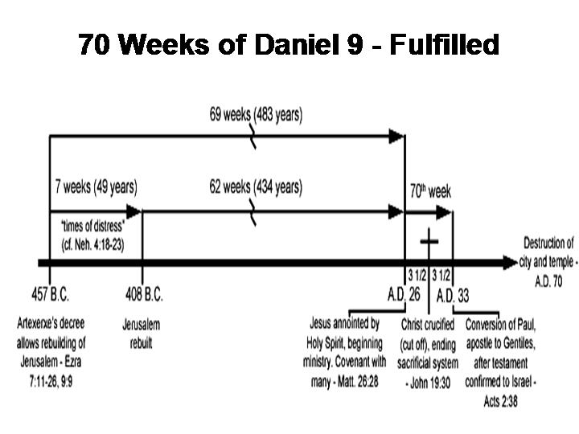

Matthew 24 Redux
“The first thing to be said of the Son of Man is that he is an eschatological figure. He has not yet appeared; but in the last times he will be revealed. [His coming] means the end of the heathen human empires of this [age], and the dawn of the Kingdom of God.”
Mowinckel, He That Cometh, p 358.

“The contrast between a present age dominated by evil and an age to come is explicitly drawn only in the later Jewish apocalypses 4 Ezra and 2 Baruch, but it is a natural development of such seminal passages as the vision in Daniel 2 and 7, was implicit in Qumran’s talk of “the time of wickedness” (CD 6.10, 14; 12.23; 15.7; 1QpHab 5.7), and was probably already part of the Jesus tradition (‘in this present age…the age to come’, Matt. 12.32; Mark 10.30; Luke 20.34-35).” Dunn, Theology of Paul, pp 40-41.
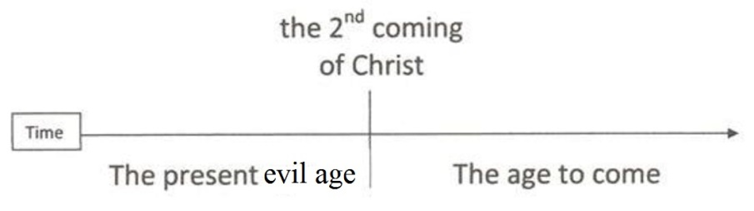

Pulpit Commentary: “In the Authorized Version, after the word "desolation," the words "spoken of by Daniel the prophet," are introduced, but without sufficient authority. They were probably interpolated from St. Matthew, where there is abundant authority for them; and thus their omission by St. Mark does not affect the argument drawn from them in favor of the genuineness of the Book of Daniel, against those, whether in earlier or in later times, who reject this book, or ascribe it to some mere recent authorship.”

Holman’s Illustrated Bible Dictionary: “The expression Great Tribulation refers to the time of trouble which will usher in the second coming of Christ (Matt. 24:21; Rev. 2:22; 7:14). Jesus warned that the great tribulation would be so intense that its calamities will nearly decimate all of life1…The allusion to Daniel 12:1 suggests an eschatological [future] view of the great tribulation…Although this event should rightly be regarded as future, attempts to connect the time of tribulation with specific events or persons [in history] have proven futile.”

The "word of the Lord" [v.15] leads at once into a reminder of the Jesus tradition, that "the day of the Lord comes like a thief in the night" (5.2, 4), and thence into a sustained exhortation to wakefulness — again echoing a characteristic theme of Jesus' parables of crisis [Matt. 24.42-43; 25.13; Mark 13.34-37; Luke 12.37. Also Mark 14.34-38 par.].
As with 1 Thessalonians, the [2nd] letter has been occasioned by a particular crisis. There it was the problem of unexpected events prior to the parousia. In this case it is the problem of escalating expectation, overheated eschatological enthusiasm. The Thessalonians had been given to believe "that the day of the Lord has come," that it was already present (2.2). [Paul's formulation, "neither through spirit[-inspired utterance], nor through word, nor through letter..." (2.2), envisages a continuing ferment, with various communications contributing to the confusion.] Paul's response was to damp down the fires of enthusiasm by insisting that crucial events were yet to intervene before the end (2.3-12).]
[This is one of the clearest examples of a paraenetic [exhortation/advice] tradition (passed on by Paul in founding a new church) whose echoes of a distinctive parable of Jesus (Matt.24.43/Luke 12.39) are best explained if Paul had repeated the parable to them as part of their foundational Jesus tradition.] Dunn, The Theology of Paul the Apostle, pp 300-302.
- Early Church and Fathers ARE futurists:
Didache (AD 100) "then shall appear the world-deceiver as Son of God, and shall do signs and wonders, and the earth shall be delivered into his hands…but they that endure in their faith shall be saved from under the curse itself. And then shall appear the signs of the truth; first, the sign of an out-spreading in heaven; then the sign of the sound of the trumpet; and the third, the resurrection of the dead; yet not of all, but as it is said: The Lord shall come and all His saints with Him. Then shall the world see the Lord coming upon the clouds of heaven." (Chapter 16)

Shepherd of Hermas, Visions 2, 2.7: c. 100AD
“Stand steadfast, therefore, you who work righteousness, and doubt not, that your passage may be with the holy angels. Happy you who endure the great tribulation that is coming on, and happy they who shall not deny their own life. For the Lord has sworn by His Son, that those who denied their Lord have abandoned their life in despair, for even now these are to deny Him in the days that are coming.”
“A virgin meets me…I knew from my former visions that this was the Church…‘You have escaped from great tribulation on account of your faith, and because you did not doubt in the presence of such a beast. Go, therefore, and tell the elect of the Lord His mighty deeds, and say to them that this beast is a type of the great tribulation that is coming.’” Vision 4, 2.5.
“For as gold is tested by fire, and thus becomes useful, so are you tested who dwell in it. Those, therefore, who continue steadfast, and are put through the fire, will be purified by means of it…Wherefore cease not speaking these things into the ears of the saints. This then is the type of the great tribulation that is to come.” Vision 4, 3.6.

Justin Martyr (AD 100-168) "Two advents of Christ have been announced: the one, in which He is set forth as suffering, inglorious, dishonored, and crucified; but the other, in which He shall come from heaven with glory, when the man of apostasy, who speaks strange things against the Most High, shall venture to do unlawful deeds on the earth against us the Christians.” (First Apology, Chapter 110)

Irenaeus (AD 180) Against Heresies, bk. 5, chs. 25-26: “In which [temple] the enemy shall sit, endeavoring to show himself as Christ the Lord also declares: ‘When you shall see the Abomination of Desolation standing in the holy place, as Daniel spoke of it…’ Everything will be given into his hands until a time of times and half a time: that is for three and a half years, during which time, when he [Antichrist] comes, he will reign over the earth…The Abomination shall be brought into the temple, even until the consummation of the time shall the desolation be complete [Dan 9:27]. Now 3 years and 6 months constitute the half ‘week.’”

Hippolytus (AD 170-235) “Now, concerning the tribulation of the persecution which is to fall upon the Church from the adversary, John also speaks thus [Rev 12]…[Rev 12.14] refers to the one thousand two hundred and threescore days (the half of the week) during which the tyrant is to reign and persecute the Church, which flees from city to city, and seeks conceal-meat in the wilderness among the mountains…The Lord also says [Mat 24.15-22]; and Daniel says [12.11]… And the blessed Apostle Paul, writing to the Thessalonians, says [2Thess 2.1-10]… These things, then, being to come to pass, beloved, and the one week being divided into two parts, and the abomination of desolation being manifested then, and the two prophets and forerunners of the Lord having finished their course, and the whole world finally approaching the consummation, what remains but the coming of our Lord and Saviour Jesus Christ from heaven, for whom we have looked in hope? who shall bring the conflagration and just judgment upon all who have refused to believe on Him…For the Lord says [Luke 21.28, 18; Matt 24.27].”
(Treatise on Christ and Antichrist, 60-64) c.202

Cyprian (AD 200-258)
Nor let any one of you, beloved brethren, be so terrified by the fear of future persecution, or the coming of the threatening Antichrist, as not to be found armed for all things by the evangelical exhortations and precepts, and by the heavenly warnings. Antichrist is coming… but immediately the Lord follows to avenge our sufferings and our wounds.” (Epistles of Cyprian, LIII, p.722)

Commodianus (AD250): “Isaiah said, ‘this is the man who moves the world and so many kings and under whom the land will become a desert’…Then, doubtless the world will be finished when he appears. He himself will divide the globe into three ruling powers, when however, Nero will be raised up from hell, Elijah will first come to seal the beloved ones…the whole earth on all sides will tremble for 7 years. But Elijah will occupy half of the time and Nero the other half…and the Latin conqueror will then say, ‘I am Christ whom you always pray to.’ And indeed the original ones who were deceived combine to praise him. He does many wonders since he is the false prophet. Especially that they may believe him his image will speak. The Almighty has given it power to appear such. The Jews, recapitulating Scriptures from him, exclaim at the same time to the Highest that they have been deceived...” (The Instructions of Commodianus, chs. 41-42).

Victorinus (AD 269-271) "He shall cause also that a golden image of Antichrist shall be placed in the temple at Jerusalem, and that the apostate angel should enter, and thence utter voices and oracles...The Lord, admonishing His churches concerning the last times and their dangers…three years and six months, in which with all his power the devil will avenge himself under Antichrist against the Church." (Commentary on the Apocalypse, 20:1-3)

Lactantius (c. 250-330 AD) “Another king shall arise out of Syria, born from an evil spirit...and he will constitute and call himself God, and will order himself to be worshipped as the Son of God, and power will be given him to do signs and wonders. Then he will attempt to destroy the temple of God and persecute the righteous people; and there will be distress and tribulation such as there never has been since the beginning of the world.” (Divine Institutes, bk. 7, ch. 17).

Cyril of Jerusalem (313-386) “For this cause the Lord knowing the greatness of the adversary grants indulgence to the godly, saying, Then let them which be in Judæa flee to the mountains. Matthew 24:16…for then shall be great tribulation, such as has not been from the beginning of the world until now, no, nor ever shall be. Matthew 24:21 But thanks be to God who has confined the greatness of that tribulation to a few days; for He says, But for the elect's sake those days shall be shortened ; and Antichrist shall reign for three years and a half only. We speak not from apocryphal books, but from Daniel; for he says, And they shall be given into his hand until a time and times and half a time. A time is the one year in which his coming shall for a while have increase; and the times are the remaining two years of iniquity, making up the sum of the three years; and the half a time is the six months. And again in another place Daniel says the same thing, And he swore by Him that lives for ever that it shall be for a time, and times, and half a time. Daniel 12:7 And some perhaps have referred what follows also to this; namely, a thousand two hundred and ninety days ; and this, Blessed is he that endures and comes to the thousand three hundred and five and thirty days. For this cause we must hide ourselves and flee; for perhaps we shall not have gone over the cities of Israel, till the Son of Man comes [Matthew 10:23].” Catechetical Lecture 15.16

